Battle of Marathon – Video 09
Most important event in Greek history?
490 BC – between Persia and Greek city-states where the Greeks were FAR outnumbered.
Persians had been undefeated.
Greek _____________________ and independence at stake.
Situation Report (Lead up to War):
Persia has gained control of all Greek colonies in ____________________ and they are pushing into Northern Greece (Thrace).
Trouble in Paradise: ___________________ is not happy about democracy in Athens.
Athens fears Sparta will invade to reestablish tyranny in Athens, so they go to ___________________ to set up an alliance.
BUT the Great King of Persia wants Athens to submit to Persia (symbolic earth and water). Persia’s idea of an alliance (total submission) is not the same as the Greek idea of an alliance. The Athenians will not submit, so they are on their own against the Spartans.
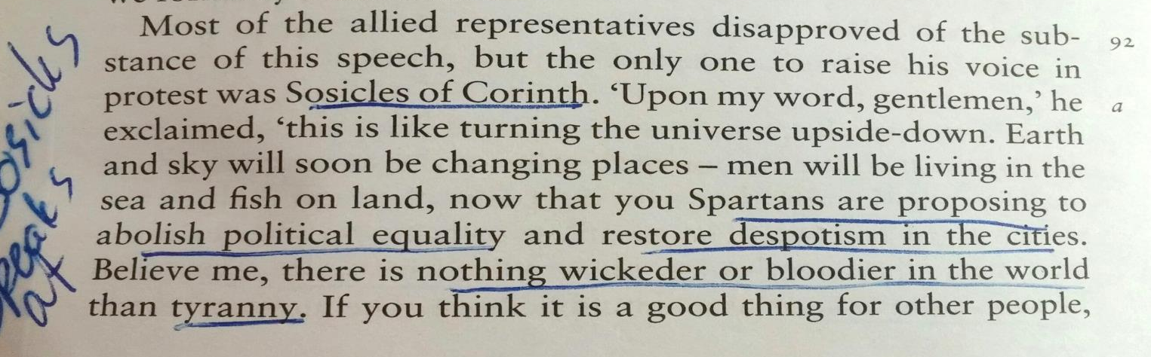
Sparta (with Thebes and Corinth) agrees to invade Athens. HOWEVER, Corinth wants to pull out because they don’t necessarily agree with tyranny.

Two Spartan kings argue about what to do with Athens:
Demaratus – wants to leave Athens alone (he loses and goes to Persian king)
Cleonomes – wants to reestablish tyranny in Athens
Interesting sidenote: when Greek politicians fall out of favor, they seem to go to Persian King and work with him. Hmmmm….
So now….only ___________________ is left to invade Athens.
Athens kicks their butts and establishes a soldier colony in the region.
Sparta is not happy Athens seems so powerful.
Sparta wants to restore ___________________ as tyrant in Athens.
Hippias had previously fled to the Persians, who would also like him to be in charge in Athens (really…both Persia and Sparta would like to control Athens).
Persia sends a demand to ___________________ to reinstate Hippias and give earth and water; Athens says NO.
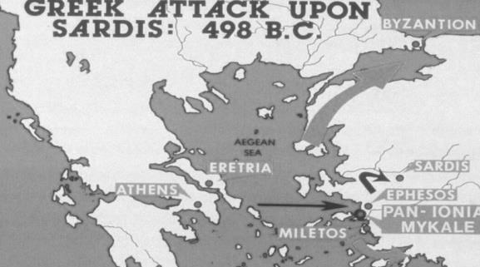
Ionian Rebellion 499 BC (Start of Greco-Persian War):
Miletus (capital of the Ionian Greek cities on the coastline of Asia Minor) starts a revolution against Persia. (Back story of how Aristagorus is in trouble with Persia for leading a failed attack against Naxos.) Aristagorus decides he will lead the Ionian cities in a rebellion against Persia.
The cities establish Athenian-style democracy.
Aristagorus goes to mainland Greece to ask for allies to fight the Persians:
___________________ says no: they don’t like to have the army gone too long.
___________________ says yes: they are close relatives with the Ionian cities and want to help protect democracy (plus protect shipping trade routes). They send a fleet of ___________________ triremes.
Athenians march with Ionians to ___________________, set fire to the city, and basically take off. (FYI Herodotus tells us a Persian temple is destroyed as well, which will be a pretext for the Persians burning Greek temples.)
Persia is SUPER PISSED and will get revenge. It takes Persia ___________ years to regain control of Ionia, and includes the burning of Miletus.
(FYI Herodotus tells us King Darius would have a servant whisper “Remember Athens” to him daily.)
*Five years later*
493 BC – Athens knows Persia is coming.
Miltiades (previously exiled) comes back to Athens and is elected archon. ___________ is also elected archon.
Persia is on its way through Northern Greece, down the Aegean coast. Mardonius is the leader of the Persian contingent. They conquer Thrace, and ___________, but a storm wipes out their fleet. Mardonius and his troops abandon their invasion.
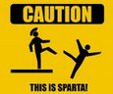
Many Greek cities, in fear, give the earth and water submissions to ___________.
___________ form an alliance with Athenians against the Persians.
King Darius asks for earth and water again – but the Athenians pushes the envoys into a ___________, and the Spartans push the envoys into a well.
490 BC – The Persians head toward Greek mainland across the ___________; want revenge and a base of operation in Athens.
Persians head to Greek islands: destroy Naxos, nice to ___________, destroy Carystus, destroy Eretria.
Persians land in the plains of Marathon, August of 490 BC, with 25,000 infantry and 1,000 ___________.
Athenians have 10,000 hoplites.
Persians chose Marathon for open ___________ (perfect for cavalry).
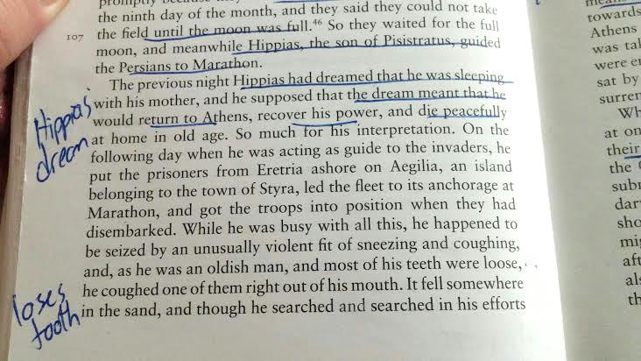
ALSO, Hippias picked Marathon, where he was from; thinking locals would defect to his side.

Athens sends Pheidippides to ___________ for help.
(FYI – Herodotus tells us that Pheidippides met the great god Pan during this run, who was insulted that the Athenians don’t pay him enough attention. The Athenians built a shrine to him after the war.)
Sparta won’t come due to a religious ceremony; cannot leave until next ___________ ___________.
Athens has two choices: hide and defend Athens, or meet the Persians on the ___________. The first plan is not a good idea – it lets the Persians too close to home, and into their countryside (farmland).
Miltiades convinces Athenians to pin down Persians on the beach (he knows how Persians work, having been a general in their army at one point).
From Herodotus: Plataea sends 1,000 men to help Athens (later Plataea is offered citizenship). Athenians had a tiebreaker for the ten generals called a polemarch: this person would side with Miltiades to attack the Persians at Marathon. Miltiades gives epic speech to break the tie:
Miltiades plans also makes sense because there are supporters of ___________ in Athens who may gain momentum. PLUS, it’s not very GREEK to stand down in the ___________ of an enemy! You must show___________, and get out there and fight! HOORAH!
Athenians block the road the Persians would need; Persians stuck on beach.
Both sides wait for several days (Persians hoping for revolt and Athens hoping for ___________ to show).
Persians pull back 10,000 forces onto ships to sail to ___________. But CRAP – there’s no one at home to defend it.
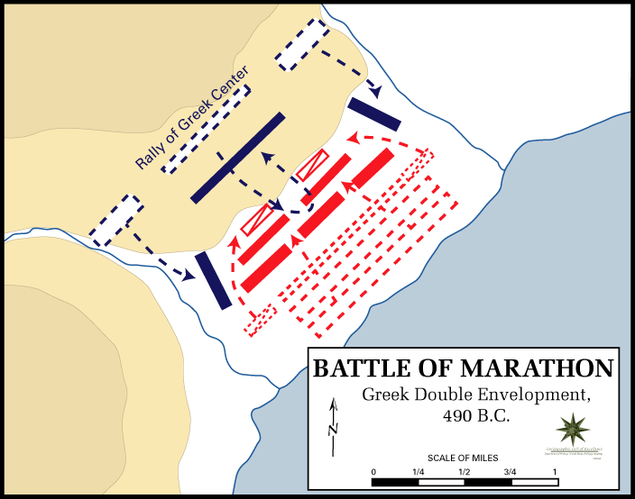
Miltiades gives the signal to advance. (FYI: Herodotus says the Athenians charged at a run.)
Miltiades weakens his ___________ and strengthens his flanks. The Athenians also have the high ground.
Athenians defeat Persians on the flanks and then back into center (basically surround the Persians).
Persians head back to ships, but are caught in the ___________, and many killed.
Athenians split army and hurry back to ___________ to protect it from Persian fleet; Persian fleet turns back as soon as it sees the army.
!!!!!!!!!!!!!!!!!!!!!!!!!!!!!!!!!!!!!!!!VICTORY!!!!!!!!!!!!!!!!!!!!!!!!!!!!!!!!!!!!!!!!!!!!!!!!!!
Only ___________ Greeks killed; several thousand Persians slaughtered.
___________ shows up a day late and is impressed.
This is the first time the Persians have been defeated.
This also demonstrated the superiority of ___________ warfare and democracy.
The Persian army is no longer ___________.
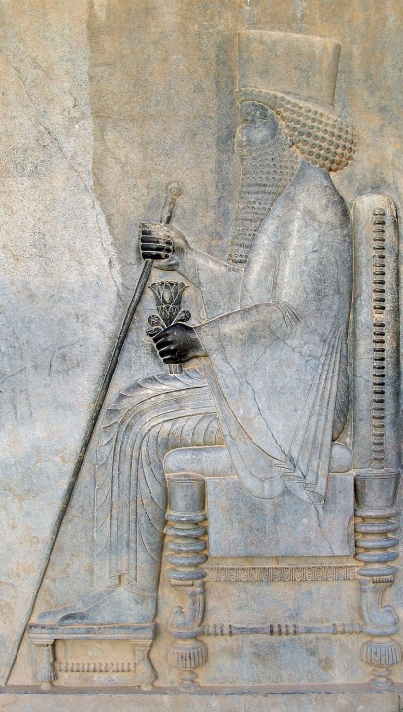
I’LL BE

BACK

