Battle of Plataea– Video 12
After Battle of Salamis – 480-479 BC
Xerxes heads home to Persia.
___________________ is left behind in command of the Persian land forces in Greece.
The Persian army controls north and __________________ Greece, but abandons Attica. They have no naval support.
Thessaly, Macedonia, and Thrace all remain loyal to Persia after the Battle of Salamis.
The Greek allies have control of Attica and the Peloponnese (strongest areas anyway!).
Athenians reclaim _______________ and begin the rebuilding process (FYI the Athenians will begin to build a wall that will piss off Sparta later).
The Allied Greeks ignore the Persians and start a propaganda war against each other, each trying to claim the victory for the Battle of __________________.
Themistocles begins to lose political leverage, because farmers/hoplites/nobles want to return to praising a land army, not the navy. The victory at Salamis seems to overshadow the victory at _______________________.
Also, the Spartans praise Themistocles and Eurybiades for the victory at Salamis, and give Themistocles a _______________________ (it was HIGHLY unusual for the Spartans to praise a non-Spartan).
When Themistocles returns to Athens, he is not elected archon. Aristiades takes control of the land army, and Xanthipus takes control of the navy.
Relations between Athens and _______________ begin to deteriorate.
Athens wants to take a land fight to Mardonius and drive the Persians out of Thessaly and Greece.
The Spartans (as usual) want to remain at home because there is no chance the Persians will invade. They prefer the policy of isolationism.
Mardonius decides to take advantage of the split, and sends an envoy to Athens proposing an _____________________ (remember the conversation with Alexander).
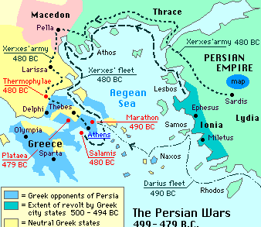
The Athenians ________________ the proposal and make sure the Spartans know it.
Battle of Plataea – 479 BC
Upon being rejected, Mardonius marches towards Attica.
The Thebans and Boeotians are wary of the Persians.
The Spartan army does not appear, so Athens is on its own.
The Athenians abandon home again and retreat to _______________________.
The Athenian fleet is mobilized, but without the Spartans, they do not want to attack by land. The Persians will not attack Salamis without a navy.
Athenians envoys are dispatched to Sparta.
Mardonius offers terms of alliance to Athens again. Athens has every reason to consider the offer this time.
The idea that Athens might actually consider the alliance this time pushes the Spartans over the edge.
Sparta agrees to ally with Athens again to take on the Persians, and sends a contingency right away.
Allied Greek army of 80,000:
- 5,000 Spartans
- 35,000 Helots (Spartan slaves)
- 5,000 Perioikoi (free, but non-citizen, inhabitants of Sparta – mostly tradesmen)
- ________________ Athenians
- Other hoplites from Greek cities
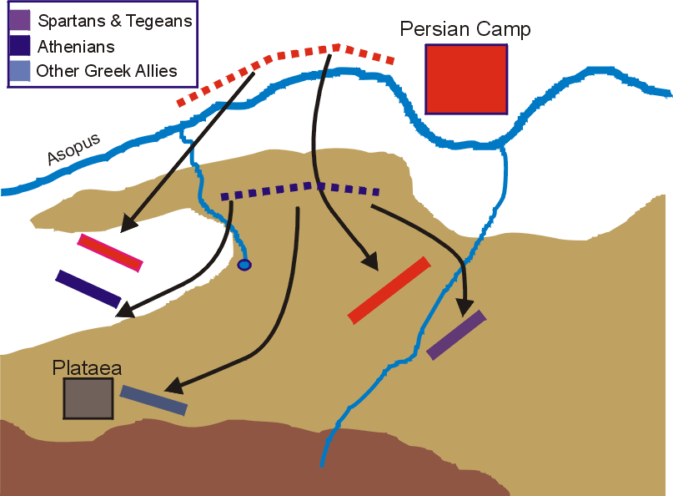
The Allied Greeks are under the command of Pausanias, a Spartan general, and nephew of ________________. He makes the entire Allied Greek army take a vow of loyalty.
Mardonius starts marching the troops out of Attica (retreating), knowing the rocky terrain would work against his cavalry. He burns Athens again.
Persians retreat towards Thebes, set up an encampment on the Northern side of the Asopus River, and wait.
He hopes to lure the Greek army into the surrounding plain, which is suitable for his ______________________.
The Persians clear the surrounding timber.
The nearest town is called Plataea, and the main road leads to Thebes (who is still friendly with the Persians). Basically, the Persians have the perfect set up.
The Greeks appear, overlooking the river, and see the set-up of the Persians. They decide to set up a defensive position across the river, with the helots protecting the rear.
The Greeks have their backs to the mountains, and thus protect the passes.
Pausanias has _________ intention of advancing any further. He intends to hang around the rocky base of the mountain, which will work against Persian cavalry.
The two armies stare at each other for ____________ days.
(Sidenote about how generals use seers and prophets to get the armies to act. Interesting.)
_______________________ breaks the stalemate by sending his cavalry on a raid to try to lure the Greeks out of their position. It fails, and the Persians lose their greatest cavalry commander.
Though a loss for the Persians, it boosts Greek morale enough for them to move forward, though still on the high ground but closer to Mardonius’ camp.
The Spartans take the right flank, the Athenians take the left flank, and everyone else is in the center.
Pause at 10:28 for what Herodotus tells us about the Greeks and the positions. After the Persian cavalry leader is killed, the Greeks parade his body around. Then, the Tegeans (small city-state on the Peloponnese, near Sparta) start arguing with the Athenians for a position of honor within the formation. The Athenians fire back, and point out their win at Marathon, but then say this to Pausanias:

The Allied Greek formation took up around ________ miles.
Pausanias is determined to keep the Greeks south of the river; he does not want to give the Persians any tactical advantage.
Mardonius cannot continue to hang around as his supplies are dwindling, and he cannot receive any supplies from the Persian fleet (because they are leaving….). SO….if he can’t get supplies, nobody can have any!
He orders the Persian cavalry to cut off the __________________ passes on the Greek flanks. This is successful in cutting off supplies to the allies.
Mardonius still will not move forward, and ___________ more days pass.
According to Herodotus, this is because both sides receive bad ___________ during sacrificial rituals.
Finally, Mardonius re-deploys his best troops and cavalry to assault the _______________ flank, knowing if he can take the Spartans, it’s all over. It’s risky – the Spartans have the high ground and it’s a frontal assault. BUT he hopes to draw the Spartans off the ridge.
The Persian cavalry cuts off the spring supplying water for the Greek army, making the situation dire for the Greeks.
The Greeks must retreat, but they must wait for the cover of ________________, in order to keep the Persian cavalry from attacking them.
The retreat goes completely wrong.
The contingents in the _________________ miss their appointed position and end up scattered in front of Plataea.
The Athenians, Tegeans, and Spartans guarding the rear had not even begun to retreat by daybreak, leaving a single Spartan division on the ridge to guard the rear, while the rest of the Spartans and Tegeans retreat uphill.
Pausanias had ordered the Athenians to retreat uphill and join up with the Spartans, but the Athenians (at first) head to Plataea.
Basically the Allied Greeks are fragmented as the Persian camp wakes up.
Mardonius notices the Greek positions are abandoned, and assumes it must be a panicked _________________. Thinking the Greeks are in full flight, he orders his entire army across the ____________ in pursuit.
In reality, the Greeks are just retreating back to their original positions to secure the supply lines.
The Persian cavalry is ordered to attack the Spartans first, while the Persian center remains still. The Spartans call on the ______________ for help.
The Athenians, however, are under assault from the Thebans.
The Spartans turn around to meet the Persians head-on. The Spartans have no cavalry, and are dependent on their heavy infantry to handle it without help.
FYI: In ancient times, an infantry can rarely withstand a cavalry charge.
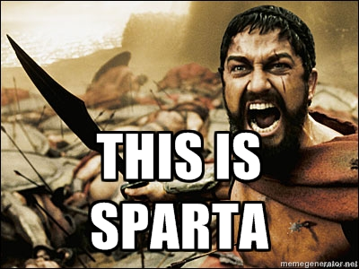
BUT THESE ARE SPARTANS! Though they take losses, the unit remains unbroken, and after a savage fight, the Spartans overcome the Persian cavalry.

The Tegeans and Spartans take on the Persian ________________ and right flank. The Persians placed most of their heavily armored units in the front ranks. But they are still no match for the Spartan hoplites.
The Spartans manage to drive a wedge though the Persian ranks. The Greeks are forced to switch to using swords as Persians attempt to neutralize their use of long spears.
According to Herodotus, "First there was a struggle at the barricade of shields; then the barricade down, there was a bitter and protracted fight, hand to hand... for the Persians would grab hold of the Spartan spears and break them; in courage and strength they were as good as their adversaries, but they were deficient in armor, untrained and greatly inferior in skill. Sometimes singly, sometimes in groups of ten—perhaps fewer, perhaps more, they fell upon the Spartan line and were cut down."
_________________ is present at the scene riding his glimmering (glittering?) white horse, with his bodyguard of about 1,000 men. While he remains, the Persians stand their ground.
But the Spartans kill Mardonius! The __________________ begin to flee.
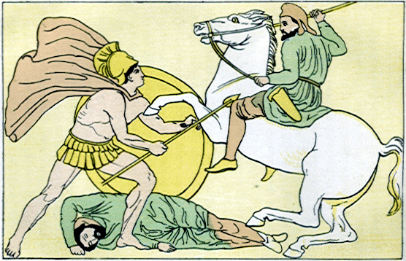
His bodyguard remains and is killed almost to the last man. At this point, the Persians have basically lost.
The _______________ left flank is able to defeat Persian-Greek allies (like Thebes).
The Spartans drive Mardonius’ wing back across the Asopus River.
The Spartans and Athenians kill almost every retreating Persian they can.
The Persians lose over 100,000 soldiers, while the Greek lose only a few thousand.
The remaining Persians retreat to their fort, and block the gates. The Greeks have initial trouble entering, but the _________________ who know how to handle a siege, are able to break down the gates. The Persians are slaughtered.
BUH-BYE, Persians in Greece.
This is the final major battle of the Greco-Persian War.
What about the Greek allies of Persia? Many left the battle as soon as it was clear the Allied Greeks were winning.
What about ______________? Punish them? They do have a massive city with good defenses.
According to Herodotus:
The victorious Greeks spent some time burying their dead, and then decided to move against Thebes. They reached Thebes ten days after the battle, and demanded the surrender of the main Persian supporters and in particular Timagenidas and Attaginus.
The Thebans refused to surrender their leaders, and so the Greeks began a siege of the city, both attacking the walls and devastating Theban farmland in the hope that this would force the city to surrender.
This policy paid off. After twenty days Timagenidas offered to surrender in order to avoid more suffering, as long as Thebes agreed to provide money to pay any ransom. Unsurprisingly the Thebans accepted this offer, and the surrender was soon negotiated. Attaginus was clearly more aware of their likely fate, and managed to escape, but Timagenidas and the other ringleaders surrendered.
Pausanias was also aware that some of his fellow Greeks were likely to accept bribes to arrange for the freedom of the Theban leaders, and so he quickly took them back to Corinth and had them executed.

After the Battle of Plataea, the Greeks erected the Serpents' Column in Delphi. Constantine the Great brought this victory monument to the hippodrome of Constantinople, where it still stands. The column once carried a golden tripod with the inscription that reads:
This is the gift the saviors of far-flung Hellas upraised here,
Having delivered their states from loathsome slavery's bonds.

FYI: The Battle of Mycale is said to have taken place the same day. Greeks went on the offensive off the coast of Asia Minor. The Ionian Greeks join the Allied Greeks in fighting off the Persians. The Athenians then entered into a formal alliance with a number of Aegean islands, including Samos, Chios and Lesbos. The Greeks then moved north to the Hellespont to attack the Persian bridges. When they discovered that the bridges had already been destroyed, the Greek fleet split up. The Peloponnesian contingents returned home, while the Athenians remained in the area and laid siege to Sestus, a Persian headquarter.

Plataea and Mycale have great significance in ancient history as the battles that decisively ended the second Persian invasion of Greece, thereby swinging the balance of the Greco-Persian Wars in favour of the Greeks. They kept Persia from conquering all of Europe, although they paid a high price by losing many of their men. The Battle of Marathon showed that the Persians could be defeated, and the Battle of Salamis saved Greece from immediate conquest, but it was Plataea and Mycale that effectively ended that threat. However, neither of these battles is nearly as well-known as Thermopylae, Salamis or Marathon. The reason for this discrepancy is not entirely clear; it might, however, be a result of the circumstances in which the battle was fought. The fame of Thermopylae certainly lies in the doomed heroism of the Greeks in the face of overwhelming numbers; and Marathon and Salamis perhaps because they were both fought against the odds, and in dire strategic situations. Conversely, the Battles of Plataea and Mycale were both fought from a relative position of Greek strength, and against lesser odds; the Greeks, in fact, sought out battle on both occasions.
Militarily, the major lesson of both Plataea and Mycale (since both were fought on land) was to re-emphasise the superiority of the hoplite over the more lightly armed Persian infantry, as had first been demonstrated at Marathon.

