Battle of Thermopylae– Video 10
After Marathon – 490 BC
Miltiades dies ______________ year after Marathon in 489 BC (disgraced in jail! What’s up with these fickle Athenians?).
___________________ becomes leading general.
Miltiades and Themistocles had ideological differences. Miltiades had represented the rich ___________________ (land army/farmer warriors).
Themistocles advocates for a stronger ___________________ (sailors/lower class).
All of Greece is wondering if Persia will come back.
___________________ believes the Persians will be back and wants to prepare for the next invasion by building a powerful fleet.
But that costs $$$$$$$$!
Athenians discover ___________________ mines.
Some Athenians want to distribute wealth to the citizens (SOCIALISM!).
Themistocles wants to invest the silver into the navy. They currently only have ___________________ ships.
Meanwhile in Persia….
Darius assembles a force of 300,000 soldiers to fight Athens, BUT he dies in 486.
His son, ___________________, becomes king. (PAUSE at 6:18 and read below.)
According to Herodotus, Xerxes needs a little convincing to attack Greece again. He first has a side mission in Egypt. He allows for debate (Mardonius pushes for war). He finally has dreams that he must attack Athens, but he needs confirmation from his uncle:

Artabanus (his uncle) has a similar dream of warning to attack the Greeks and councils Xerxes to do so. (PLAY from 6:18-6:57. PAUSE and read below.)
Xerxes attempts to cross the Hellespont by building pontoon bridges. The first attempt fails due to a ___________________.
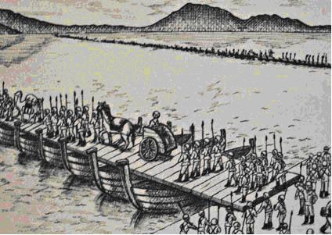
He had the Hellespont whipped ___________________ times.
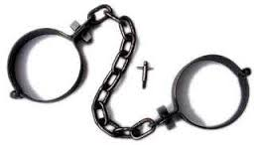

Fetters = chains
Think that’s bad? That’s not all he did….

But wait…it gets worse….
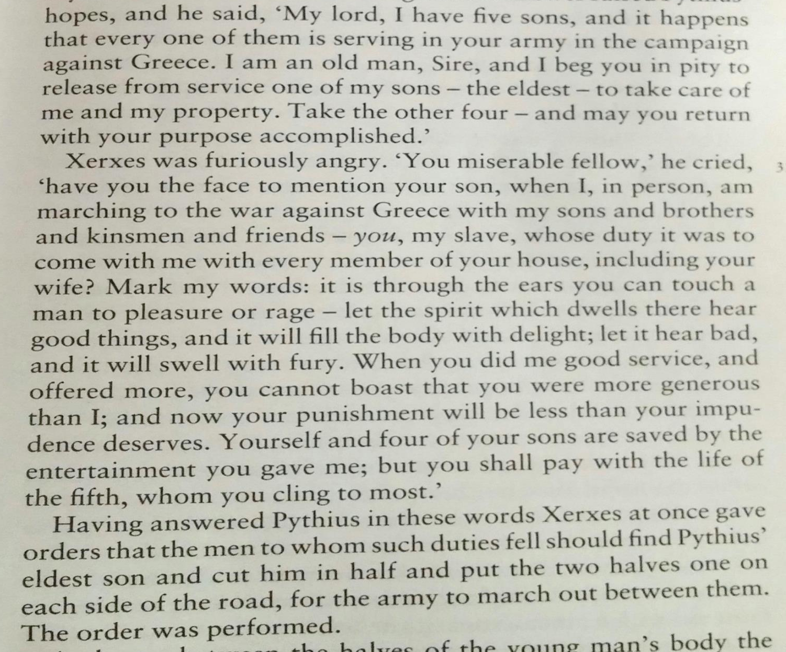

(PLAY video again.)
Xerxes’ second attempt to cross the river works and the Persians are on their way.
The Athenians build a massive fleet of triremes.
Xerxes sends envoys to all the city-states around Greece EXCEPT Athens and ___________________. The envoys have some success; city-states submit to Persia out of fear (Argos, Thrace, Macedonia).
Only ___________________ city-states will join Athens and Sparta against Persia.
The city-states that will resist Persia meet at ___________________ in 481 BC; they form an alliance in the face of a common enemy (wow….setting aside all their tensions and differences to work together…. #squadgoals).
___________________ did NOT join the Greek confederation; they remained “neutral,” and so were not trusted by the Greeks (remaining neutral was a great debate in Thebes, and 400 Theban hoplites end up joining the Spartans at Thermopylae).
The Persians move slowly, and have plenty of time because the Greek city-states that submit to them help with food and supplies. (The army was so massive there was a week’s marching time between the front and rear. DAMN.)
(PAUSE at 11:32) Here is precisely what Demaratus said to Xerxes:

(PLAY again)
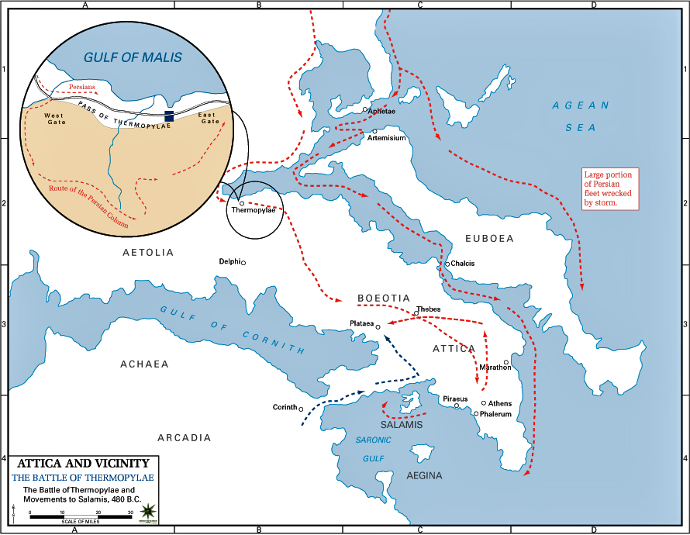
It’s Going Down For Real….. The Greeks meet again in 480 BC to discuss their plan.
___________________ suggests a two-pronged approach:
- Use the army to block the pass at Thermopylae
- Use the navy to block the straits of Artemisium
- Back-up plan: defends the isthmus of ___________________
- Women and children abandon Athens to the Peloponnese
The ___________________ lead the land contingent at Thermopylae (King Leonidas); about 4,000-5,000 men, mostly Arcadian peasants, but 300 Spartans.
Only 300 Spartans? Yup – everyone is thrilled with that. They’re freaking Spartans.
Some debate over who would lead the navy – of course Sparta wants to be in charge, but the Athenians have more experience with the navy.
___________________ is selected to lead the fleet, but the Sparta admiral Eurybiades will be second in command. (Mutual respect between the cities.)
The Persians needed to be blocked by land and by sea in order to win.
Battle of Thermopylae – 480 BC
Thermopylae is a narrow pass from northern to southern Greece. It was also called the _________ Gates, because of the springs at the foot of the mountain.
Securing this pass is necessary to protect Southern Greece.
Good position? They’ve got the mountain protecting the left flank, and the gulf protecting the right.
OOPSIE - there is a hidden path through mountains the Persians could use….Leonidas does not send any __________________ to defend this path, only other Greek warriors. This is a gamble.
Did the Spartans know they wouldn’t win? They want to create a stalemate, they have to leave reserve troops at home, and they need to hold the pass just to buy time.
Xerxes offers an alliance for the Spartans to leave the pass. Leonidas says nope.
Xerxes’ army waits 3 days. __________________ stands in front of his army, while Xerxes is in the back of his. (Runs in the family?)
Persians order the army to lay down their weapons. Leonidas replies, “__________________________________________________”
Xerxes starts with a frontal assault and a hail of arrows; they don’t do much.
Xerxes sends about __________________ soldiers; but it’s a catastrophe. The wicker-armored Persians are no match for heavily armored Greeks.
Xerxes sends his body guards, the __________________, but the same result.
End of Day 1 – Persians lose.
Day #2 – Xerxes send his best warriors and threatens __________________ if they lose. Despite this, Xerxes has to call off his failing troops.
Luckily (for the Persians) a __________________ traitor named Ephialtes reveals the hidden path to Xerxes, and takes the Immortals to outflank the Greeks.
Leonidas has no chance to get reinforcement. He __________________ most of the Greek army, while he and the Spartans decide to remain and take their last stand. He also hopes to hold the pass as long as possible to allow the Greek units to escape.
Well….and Spartan glory is cool, too.
The Spartans eat breakfast, and famously say that “tonight, we will dine in __________________.” He tries to send to messengers to Sparta, but they refuse to leave.
(PAUSE at 21:43 and read below)
Herodotus tells us the Spartans performed funerary rites for themselves before battle. Herodotus also tells us that by staying to fight, Leonidas is fulfilling a prophecy:

(PLAY again)
Day 3: Spartans wait in complete silence and Persians use synchronized attack from both sides. Spartans fight with everything they’ve got, including fists and teeth.
The Spartans fight for the body of __________________, but it makes no difference because every Spartan and allied Greek are killed, except a few Thebans who surrender.
The Persians lose at least __________________ soldiers, which had to make Xerxes wonder what would happen when he faced a whole army of Spartans.
This is a victory for the Persians, BUT the __________________ of the Spartans’ last stand becomes a “rallying cry” for Sparta and the allied Greeks. It increases morale, inspiration, and motivation for the next round of battle.

Battle of Artemisium – 480 BC
This naval battle occurrs at the same __________________ as the Battle of Thermopylae.
Day 1: The Persians lose __________________ ships to the Greeks (plus storms in the Aegean cause considerable damage). Day 1 – Greeks win.
Day 2: Persians attempt to repair their fleet, and the Greek allies receive reinforcement of __________________ ships from Athens. In the afternoon, the Greeks attack and destroy a Persian patrol. Day 2 – Advantage Greeks.
Day 3: Persians are ready. Greeks attempt to block the strait. Battle rages all day. When both sides disengage at nightfall, they have suffered roughly _____________ losses. However, the Greeks cannot keep this up because they are so outnumbered (they lose ½ their ships).
The Greeks debate withdrawing, knowing they cannot last another day.
They hear about the loss at Thermopylae, and realize that holding the strait of Artemisium no longer serves a strategic purpose.
They decide to evacuate.
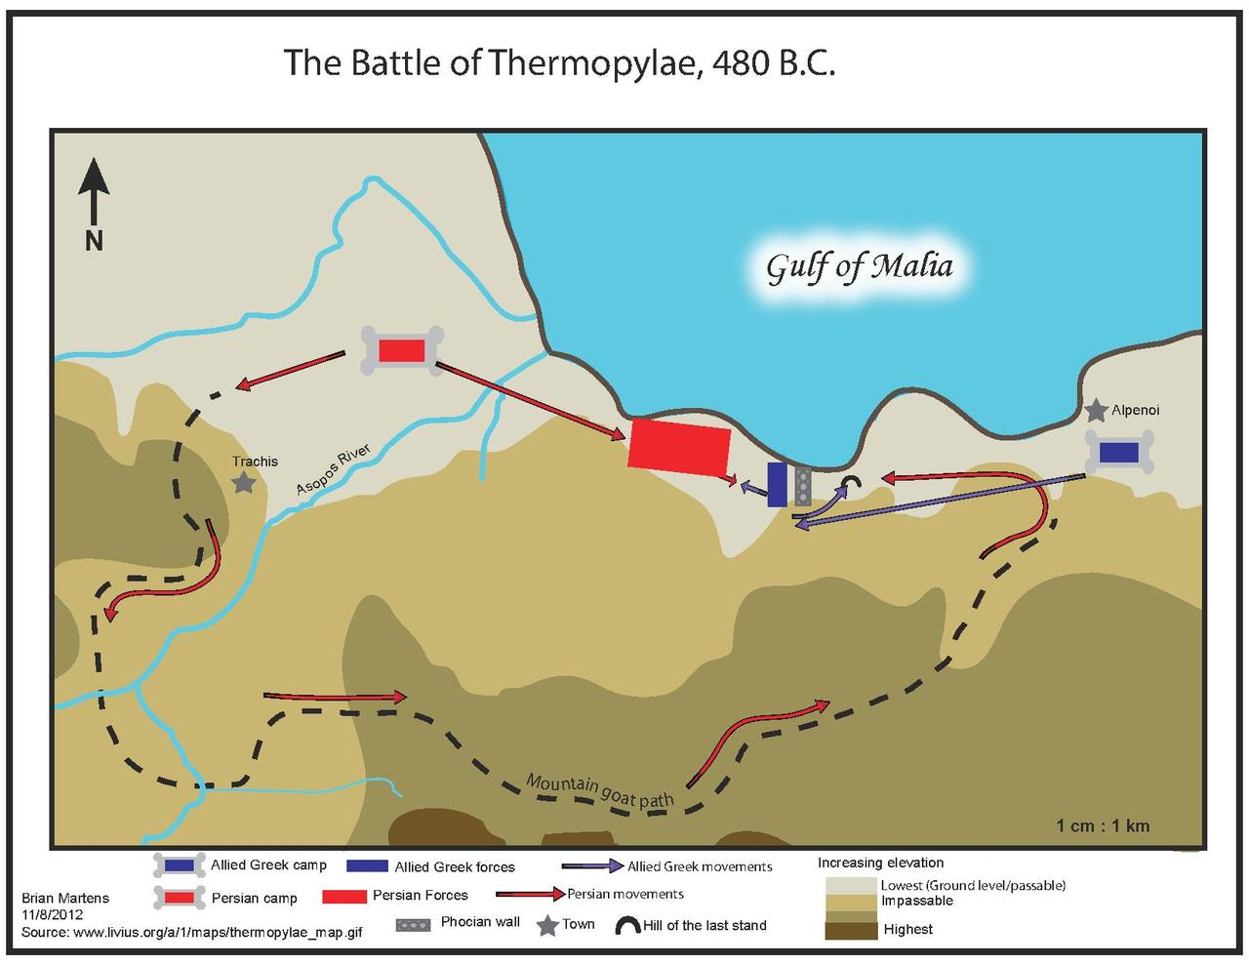
They may have retreated, but they proved to themselves they can take on the Persian navy, which boosts __________________.

Demaratus helps the Spartans:

