Greek Heroes and Myths
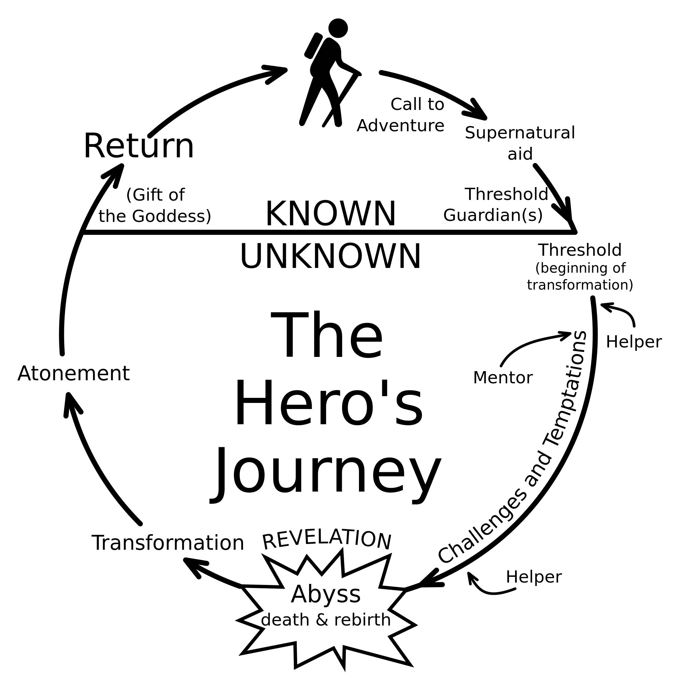
Most myths have a hero who is brave, clever or strong. Some examples are Perseus, Achilles, Odysseus, Jason and Harry Potter. The hero brings important gifts to his people (e.g. fire). He is a role model of right behavior and is greatly admired.
The life story of a mythical hero usually follows this pattern:
- He has a special birth.
- He has unusual skills as a child.
- He is tested physically and/or mentally.
- He goes on a journey or quest to find something.
- He has a mentor and/or an ally.
- He has difficult tasks to do, that may lead him to one culminating task.
- He has a weakness.
- He may suffer a sort of death/rebirth.
- He is rewarded for his effort, and often brings something back to his people.
- He may die a special death.
Pick one of the hero myths in your book and provide examples of each main event listed above:
Theseus, Heracles, Jason, Perseus, Bellerophon
Hero Pattern | Hero:
Does he have a special birth and/or special skills?

How is he tested?

Where does he journey?

Does he have a mentor or friend?

What difficult tasks does he perform?

What evil forces or monsters does he fight?

What is his weakness?

What is his reward?

What is his fate/death?

What is the deeper moral or lesson learned from the myth?

What are some of the qualities of the gods in this myth, according to their actions?

What are some of the qualities of a hero, according to his actions?

We are going to read about historical figures who grew up learning these myths the same way you have learned the stories of Cinderella, Romeo and Juliet, King Arthur, etc. Based on your summer reading, what do you think the assumptions, beliefs, or values may be of these Ancient Greek leaders?

